University of Canterbury

Robocup Progress Report 1

Group 10

Jack Hendrikz  
Peter Nicholls  
Ryan Taylor

22 May 2015

Contents

[0.0 Executive Summary 2](#_Toc419965618)

[1.0 Introduction 2](#_Toc419965619)

[2.0 Requirements Specification 4](#_Toc419965620)

[2.1 General 4](#_Toc419965621)

[2.2 Identification 4](#_Toc419965622)

[2.3 Movement 4](#_Toc419965623)

[2.4 Collection 4](#_Toc419965624)

[2.5 Construction 4](#_Toc419965625)

[2.6 Safety 4](#_Toc419965626)

[3.0 Design Space and Concept Generation 5](#_Toc419965627)

[3.1 Navigation Sensors 5](#_Toc419965628)

[3.2 Locomotion 1](#_Toc419965629)

[3.3 Tactics and Navigation 2](#_Toc419965634)

[4.0 Proposed Concepts 3](#_Toc419965638)

[4.1 Concept 1 3](#_Toc419965639)

[4.2 Concept 2 5](#_Toc419965640)

[4.3 Concept 3 5](#_Toc419965641)

[5.0 Concept Evaluation 6](#_Toc419965642)

[5.1 Evaluation of Concept 1 6](#_Toc419965643)

[5.2 Concept 2 7](#_Toc419965650)

[5.3 Concept 3 8](#_Toc419965657)

[5.4 Final Comparison 9](#_Toc419965664)

[6.0 Conclusions and Recommendations 9](#_Toc419965665)

[Contribution Statements 10](#_Toc419965666)

# Executive Summary

A search and retrieval robot must be designed for the 2015 Robocup challenge. This robot must autonomously search for packages in an arena and return them to its HQ. It was determined that the ideal concept design for this challenge is Concept One as it has a robust design with a retrieval method that can pick up the packages in varying orientations using magnets. It also employs a sophisticated path finding program allowing the robot to navigate the arena with minimal difficulty, therefore ideally suiting it for efficient package retrieval.

# Introduction

In this year’s Robocup Zombie apocalypse teams will design robots that search autonomously for food packages. The robot will compete in the arena against another robot for these packages. The battle will take place in a hostile environment, including unmoveable obstacles, walls, and a series of rough sections of ground all unknown to the robot. The robot will need to return the food packages to the team’s headquarters. Food packages consist of cylindrical weights made from steel and will be placed in both easy and hard to reach places.

Three concepts will be presented and evaluated to overcome this design problem. The three main areas for design will be the navigational sensors, locomotion and tactics. A merit table will be presented and a final recommendation will be suggested.

# 2.0 Requirements Specification

## 2.1 General

1. The robot will be fully autonomous
2. The robot will be controlled be the Arduino Mega ATK supplied
3. The robot shall be able to move, identify and collect packages
4. The robot shall operate until all 11 packages are claimed or the time limit is reached

## 2.2 Identification

1. The robot shall be able to identify food packages
2. The robot shall be able to identify obstacles it cannot move over
3. The robot shall be able to distinguish home HQ and the opposition HQ
4. The robot should rely on a range of navigational sensors

## 2.3 Movement

1. The robot shall be able to move over obstacles at least 25mm in height
2. The robot shall be able to fit through gaps of at least 500mm in width
3. The robot shall be able to manoeuvre around obstacles it cannot move over
4. The robot shall not leave the designated arena during the competition
5. The robot should not get stuck in any algorithmic loops for longer than 1 minute

## 2.4 Collection

1. The robot shall be able to pick up a package so that it is under the robots control
2. The robot shall have a way of carrying, at most, three packages without hindrance
3. The robot shall not collect any packages within the opposition’s HQ
4. The robot should be able to release any packages it has on-board to HQ
5. The robot should be able to pick up packages in any orientation and any part of the map

## 2.5 Construction

1. The cost of additional items shall not exceed $50 (except for R5.2)
2. Each member shall design their own PCB for use on the robot, not exceeding $5
3. The robot should be built with less than 200g of 3D printer plastic.
4. The robot shall be easy to maintain and disassemble

## 2.6 Safety

1. The robot shall not cause any deliberate damage to anything or anyone
2. The robot shall have an accessible ‘off’ switch
3. The robot shall use the battery safety circuit provided

# 3.0 Design Space and Concept Generation

- Discuss how the systems fit together. Context diagram! 0

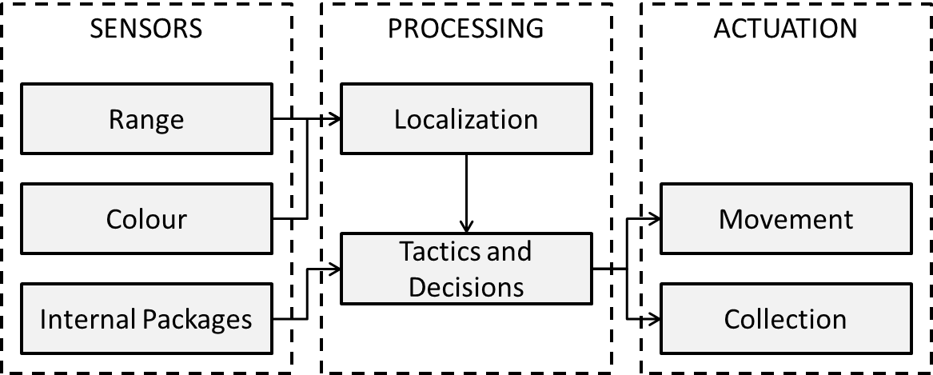

Figure

## 3.1 Navigation Sensors

A mechatronic system relies on interacting with the world around it; it uses sensors to see and give feedback to decide what the system should do. The robot we will design has a wide range of sensors available. The following sensors are provided:

* 2 × Ultrasonic Rangefinder
* 1 × Infrared (Short range)
* 1 × Infrared (Medium range)
* 3 × Infrared (Variable range)
* 1 × Infrared camera
* 1 × Sonar
* 1 × Colour detector
* 1 × Weight sensor
* 2 x Limit Switch
* 1 x IMU

### Navigation

To navigate around the arena, sensor feedback will be needed to give distances to objects around the robot. Ultrasonic and IR sensors give distance feedback ranging from 40mm to 5000mm. IR gives close to medium range with a small beam angle and ultrasonic gives medium to long range with a large beam angle. If either was used individually, it would work but be unreliable in some situations. Using both types of the sensors at the same time will help to give the microcontroller reliable results in terms of distance and angle. The downside to the ultrasonic is it has a 100ms measurement cycle compared to the IR 30ms measurement cycle. In addition to these two sensors, the sonar is also capable of measuring distances although it is much less consistent. While we could use the limit switches for navigation, they could be put to better use inside the robot.

An IR camera is also supplied, this camera can see IR or fire sources. Since there are no fires in the arena, the only source would be IR from the other robot provided they have used IR sensors. Knowing where the other robot would be useful, however the camera would only detect the opposition robot when it was pointing its IR sensors at our camera.

A powerful IMU is supplied this has a three axis accelerometer, three axis gyroscope, barometer and compass. Complete control is given over the different sensors allowing any sensor on the IMU to be used or not used. For navigating the arena a compass would be very useful giving a heading for the robot and the accelerometer would be good to sense if the robot was started moving or suddenly stopped.

### Package Detection

For detecting the packages, several methods could be used, but the most reliable would be a sensor fusion of two distance sensors. Nothing in the arena is as short as the packages, meaning that if there is a difference in length between a high and a low sensor, then there must be a package. This can be arranged so that it can detect packages if they’ve fallen over as well, as seen in Figure 2.

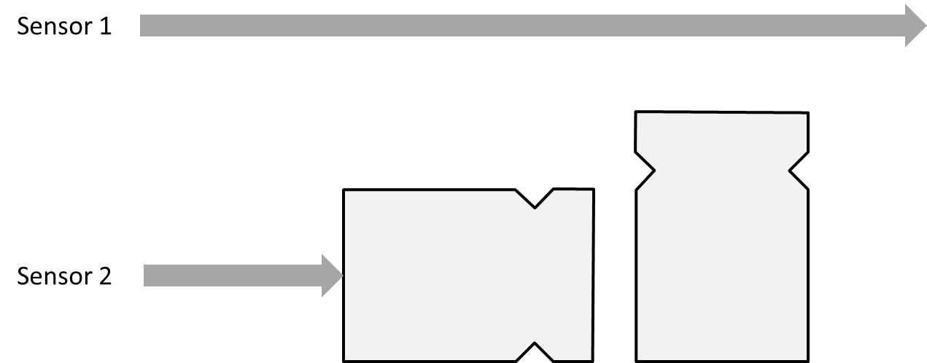

Figure : Package detection using sensor fusion

In order to comply with R4.3, the robot needs some way of telling how many packages are on board. The limit switches supplied would be ideal for this job, although it would be very important to get the switch positioned well.

A weight sensor supplied is able to measure a load itself. It uses a strain gauge to measure the weight. More points are awarded for the heavier packages. This means the heavier packages are more valuable when picking them up. With the limitation of only having three packages on board having three light compared to three heavy could be a loss of half the points. Implementing the sensor mechanically to have the correct reading will be quite hard as the picking up or holding system will have to be suspended by the sensor. This sensor is digital, with serial output.

### Finding HQ

Instead of just ‘remembering’ where HQ is, the colour sensor could be used for detecting whether the robot is in a base or not, and further to detect which base it is in. It is important to be able to determine the bases apart for requirements R2.3 and R4.4. The robot cannot pick up packages from the other team’s headquarters so the robot will need to prevent its mechanism for package retrieval. Once three packages are on-board the robot will need to return to HQ to drop them off. The colour sensor will confirm that it has arrived before it starts to drop them off.

## 3.2 Locomotion

In industry, robots have a large range of locomotion options that vary depending on the surrounding environment and the tasks that the robot must undertake. The designed robot must have the ability to manoeuvre around its environment in a way the packages can be picked up efficiently and quickly. It will be constructed to allow it to tackle obstacles such as ramps, walls and the other robot whilst in the arena. This can be achieved through both a reliable and robust locomotion method and chassis design. There are two locomotion methods that can be implemented on the robots in this arena search and retrieval scenario, wheels and tracks.

### Wheel Locomotion

Wheels are a common occurrence in mechatronic designs as they allow for simple locomotion by being actuated by the motors directly. They have a variety of steering methods from differential steering (driving like a tank) to crab driving where each wheel is driven separately. Wheels can provide a much faster robot as there is less power required to drive them in comparison to tracks.

### Track Locomotion

Tracked robots fair far better on uneven terrain due to the traction advantages as a result of increased surface area and low ground pressure. They are common on robots that operate out in the field as they can handle a wide range of terrain challenges that could not be tackled easily by a wheeled design. Turning can be achieved by slowing or reversing one of the tracks to enable pivoting on the spot.

### Locomotion Comparison

The main issues faced using a wheel locomotion design is the lack of manoeuvrability. The turning of the robot would be tricky to construct as only two DC motors are provided to drive the robot. This means that a complex driving system would have to be designed in order to either pivot the front wheels for turning. Alternatively the robot could employ skid steering which is very unreliable for the robot which needs to know its position at all times. Wheels also struggle to traverse uneven terrain as they lack traction without a suspension system or large tyres. Tracked robots generally have a more complex design and can suffer from a lack of speed since more power is required to drive the tracks. Using the traction belts provided with the robot, the belt must be kept taught to prevent slip of the motor and a loss of driving ability.

Overall tracks appear to be the best method of locomotion as they will allow the robot to manoeuvre around the arena’s terrain at a reasonable speed whilst maintain stability. Using 3D printed drive wheels for the tracks will allow our group to optimise the performance of our tracked robot design by increasing torque and applied tension to the belt.

### Chassis Design

The chassis must be built in such a way that the robot will be stable, light and allow for maintainability. To improve stability, the centre of mass must be as central and as low to the ground as possible. This will reduce the risk of the robot potentially tipping over and becoming stranded. Another key aspect to chassis design is weight as this will not only help provide traction via the tracks, but can also effect the speed at which the robot can manoeuvre at. Ideally a balance must be struck to allow a fast travelling tracked robot with a good amount of traction to scale obstacles in the arena. The chassis design should also take into account other components such as batteries, sensors and how easily they can be accessed and rewired during the construction and testing of the robot.

The chassis provided is constructed from sheet metal and aluminium support beams. It has a wide base to improve stability and a large amount of mounting holes for the components. A lighter and more compact chassis could be designed given enough time and money, but we believe this chassis will be fit for purpose for our robot construction.

## 3.3 Tactics and Navigation

Unlike previous years, our robot is required to return the food packages to the headquarters. This significantly increases the complexity of the problem, and leaves essentially two solutions (each with subsets). The robot must:

1. Have some way of reliably returning to the headquarters, or
2. Collect the heaviest packages it can find and hope for the best.

As such, two tactics have been formulated that can return to the headquarters, and one which relies of differentiating between light and heavier packages.

### Tactic 1 – Strategic Speed Runs

Figure .1: Strategic Speed Runs

The further into a round it gets, the more packages the opposition will most likely have. That is why it’s important to collect the packages as quickly as possible. The fastest way to do both collect packages and return to headquarters consistently is to have some kind of Simultaneous Localization and Mapping (SLAM) algorithm. Using the data that it has collected, it would then use the D\* pathfinding algorithm to navigate its way throughout the map. While this would create significant advantages in many areas, it would need to be able to differentiate between temporary obstacles (packages and opponents) and permanent ones. The complexity is such that it may not be able to function well enough in time for the tournaments.

### Tactic 2 – Perimeter Collection

Using a significantly simpler code, the robot could still exhibit a similar behaviour (as seen by comparing Figure 1.2 and 1.2). If it follows the edge of the arena, only deviating in order to pick up packages, it can turn and follow the edge in the opposite direction and get to its headquarters. While this method could collect a large number of packages due to the layout of the map, there are multiple drawbacks. If the robot deviates from the outer wall, then it could find itself rotating about a loop or not able to return to headquarters. There are many ways this could happen which include:

Figure .2: Perimeter Collection

* Moving to collect a package.
* 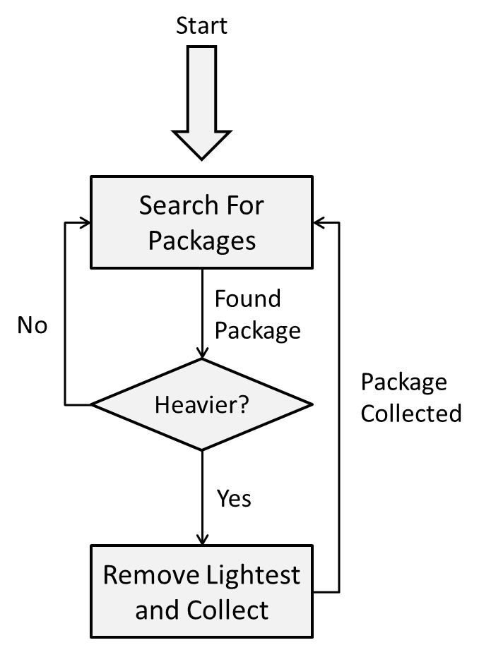Avoiding the opponent’s headquarters.
* Avoiding the opposing robot.

### Tactic 3 – Weight Optimisation

Finally, it is a valid tactic to ignore the headquarters completely. The robot would pick up three packages initially, and then each one after that would be weighed and compared with those on board. If heavier than any on board, the robot would replace the lightest package with the new one. Using this method, it could end with a maximum of three kilograms of food on board. Other non-weight discriminating tactics may have to pick up a total of twelve packages to get the same total mass. One simple addition to this tactic is to check to see if it’s in a headquarters (It will need to anyway in order to comply with R4.4). If in its own HQ, the robot can drop the packages and continue.

Figure .3: Weight Optimization

# 4.0 Proposed Concepts

Each of the three tactics discussed in Section 3.3 has been built on to become a full concept. The sensor used and propulsion methods will remain constant for reasons mentioned Sections 3.1 and 3.2, but each will have different package collection methods. Table 1 shows the difference between concepts.

|  |  |  |  |
| --- | --- | --- | --- |
|  | Concept 1 | Concept 2 | Concept 3 |
| Incorporated Tactic | Strategic Speed Runs | Perimeter Collection | Weight Optimization |
| Package Collection | Magnetic Arms | Electromagnetic Skirt | Scoop |

Table : A list of the different aspects of each concept

## P:\Robocup\IMG_0471.JPG4.1 Concept 1

Pathfinding will be used to navigate the robot around the arena. Once a package is seen the robot will use a magnet to pick it up. The robot will drive up to a package and it will attach to a magnet. A localized button will register when the package is attached. The whole picking up assembly will rotate so the packages don’t get knocked off and to ensure the no package are picked up in the other teams headquarters as seen in figure 8. Figure 9 shows the position the pickup assembly will be in when the robot is travelling around. There are three magnets one for each package, once three are on board the robot will drive back to the headquarters to drop the packages off by retracting the magnets and knocking off the packages. This process will be repeated until the end of the round. Figure 10 shows the state machine the robot will use to execute the task. Figure 6 shows the sketch of the robot.

Figure , Concept 1 overall sketch

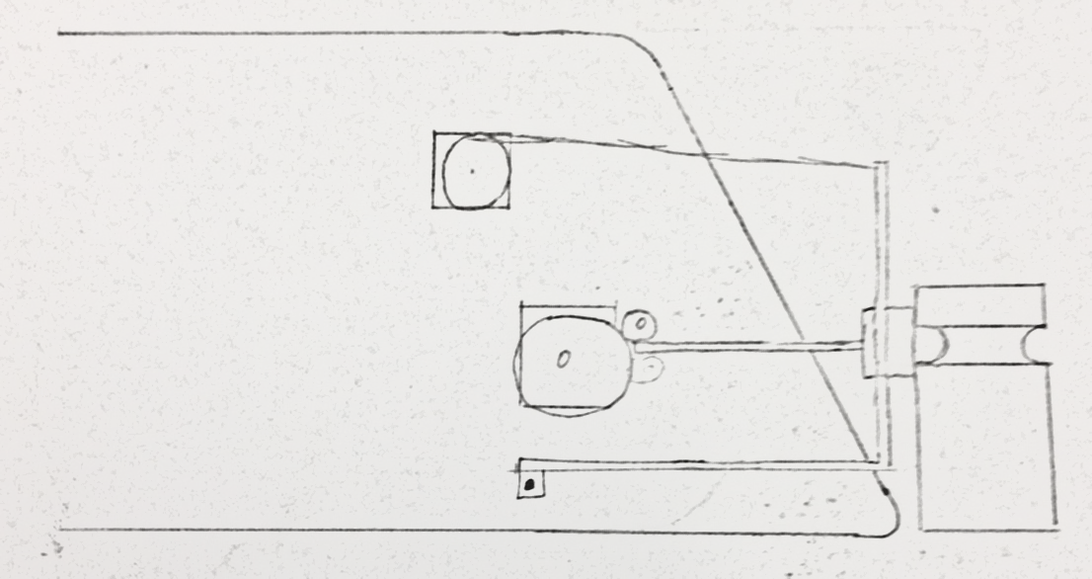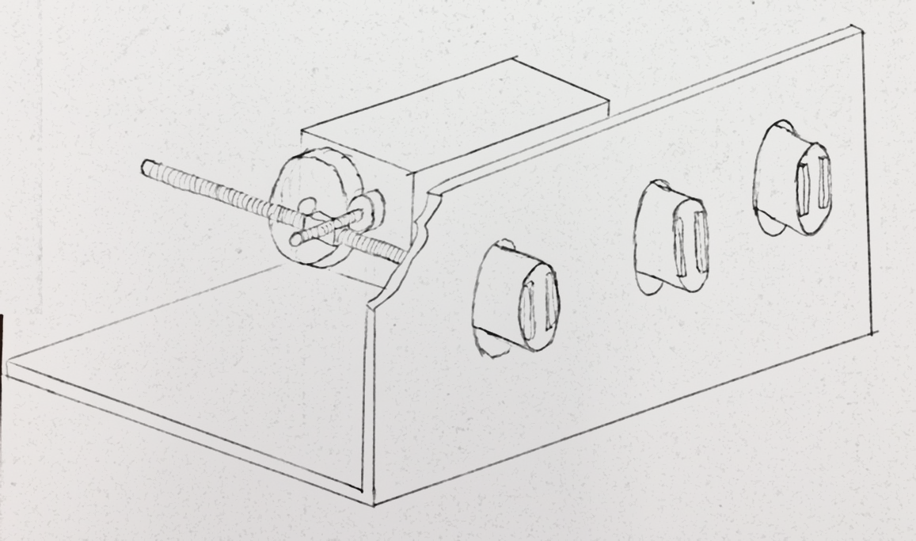The magnets used will be strong enough to pick the packages up in any orientation. The magnets are strong, so a powerful method of detaching the packages is necessary. All of the magnets will be linked and will retract together. A Perspex shield will allow the magnets to pass though and packages will drop off in the headquarters. Two geared stepper motors will be used to drive the mechanism. The retracting of the magnets may take a while to complete but is worth it because of the power of the magnets. Figure 7 shows the picking up assembly with magnets, showing internal gears needed.

Figure , Sketch of pickup assembly

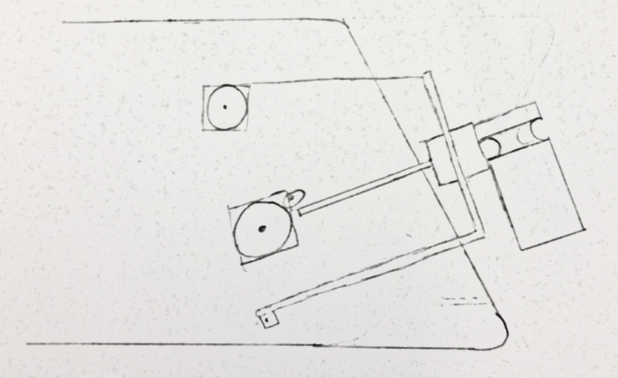

Figure , Pickup assembly lowered

Figure , Pickup assembly raised

The performance of the magnets were tested on the packages, the results are as follows.

Table , performance of magnets in Kg

|  |  |  |
| --- | --- | --- |
| Flat | Curve | Edge |
| 15.4 | 12.5 | 8.6 |
| 15.7 | 12.4 | 7.8 |
| 16.1 | 13.4 | 8.8 |

IR, ultrasonic and colour sensors will be used to aid the pathfinding. IR and ultrasonic will give the position to the walls and obstacles. Ultrasonic will be placed on the front of the robot giving pathfinding a wide angle at the front of the robot to see. IR will be placed on all four directions of the robot, front, back, left and right. Low mounted IR sensors will find the packages. Colour will be used to detect what area the robot is in, this will be placed under the robot.

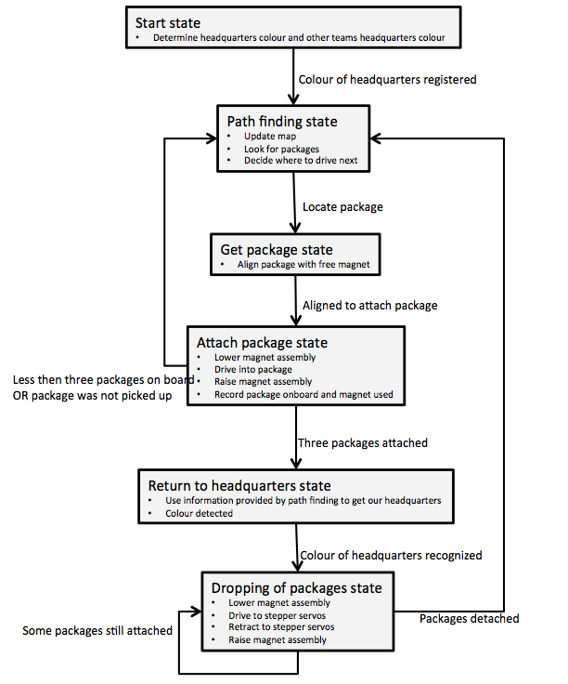

Figure 10: Finite state machine for concept 1

## 4.2 Concept 2

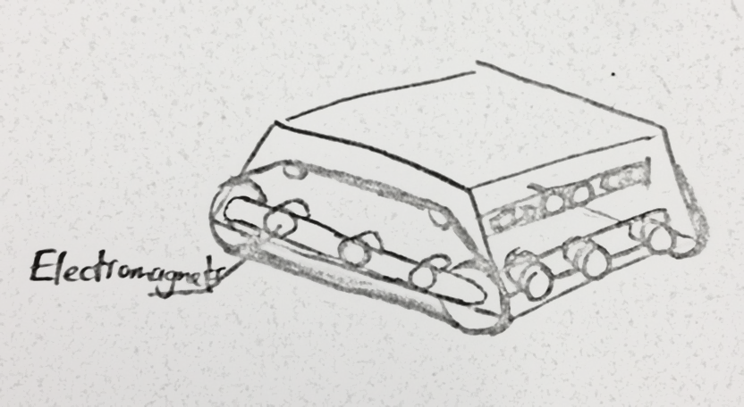Since this concept would ideally continually follow the outer wall, it would be useful in many cases if it had the ability to collect packages from not only the front but also the sides. This robot will have an electromagnet along all four sides so that it only needs to drive past the package to attract it. This has many advantages including:

Figure

* It will collect packages in obscure corners as well as ones in the open
* The robot does not need to stop to coordinate any mechanism on the front
* There is no limit to the number of packages it drags behind it, as they are not on board (R4.3)

To avoid collecting from the opposition’s HQ, it will simply turn around and return to HQ again, following the wall. Since the packages are not technically on-board (a violation of R4.1), returning to HQ is crucial for this concept to work. Once it has returned to the headquarters, it will de-activate the electromagnet until out of the HQ and continue in the same direction. Using this algorithm, the robot would collect all the packages around the perimeter up to the opponent’s HQ on each side.

The robot must also be able to detect if it has collided with the other robot so that it can temporarily turn off the electromagnet. The one major downside of this concept is that it would require a very high current draw on the batteries to achieve enough force to keep the packages.

The electromagnets considered for this concept were 12V, 3W magnets with a holding force of 25N. This force is sufficient to hold the packages, but will only attract the heaviest packages from just over 1mm away. The current draw is discussed further in Section 5.2.

## 4.3 Concept 3

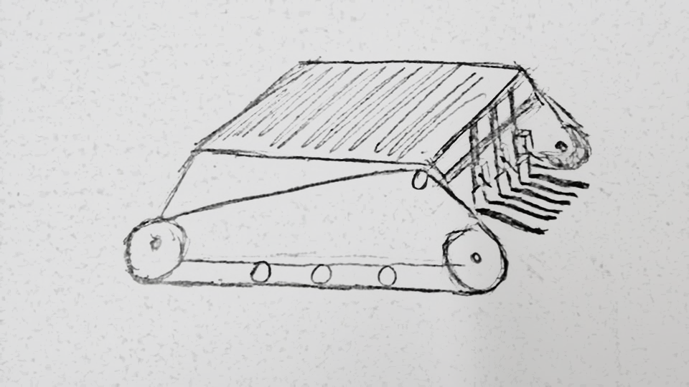The third concept design is based on a robot that will not actively seek to return to its headquarters. It will instead travel in random directions around the arena, avoid collisions with obstacles, and pick up the heaviest package it can find. Since the robot is traveling in arbitrary directions it will not need to know where the headquarters is and will therefore not need a complicated pathfinding program. The use of IR and ultrasonic sensors will be essential to detecting and avoiding collisions with objects in the arena. A sketch of this robot can be seen in figure 12.

Figure : Concept 3 sketch

This design relies on the speed of the robot as it must pick up the packages before they are either knocked over or stolen by the opposition robot. This will require the robot to have a power management system, allowing more power to be directed to the DC motors, thus improving the overall speed of the tracked design. The use of larger driving wheels will provide more power to manoeuvre the robot over obstacles.

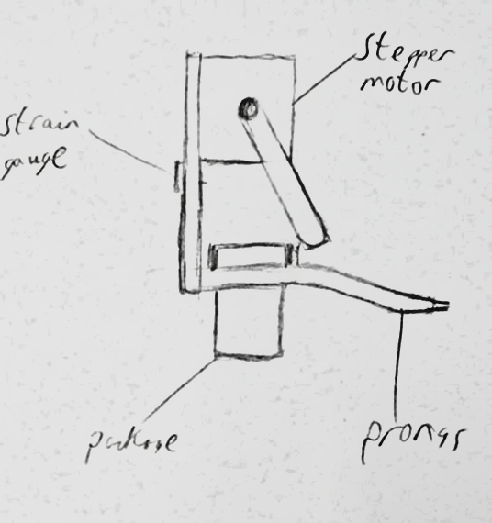The robot must also have the ability to eject and pick up packages of varying weight efficiently and reliably. Once a package is found it will be picked up by one of the three prong scoops on the front of the robot. The prongs will sit on the grooves of the package to and lift it slightly off the ground, ensuring the package is on board. Hall Effect sensors will be used to detect packages and help position the prong scoops to pick them up. The weight of the collect package is then measured by a strain gage and stored in Arduino’s memory. If the robot is carrying the maximum amount of packages then it will determine the lightest package, eject the light package, and pick up the heavier one. Ejection is done by using a stepper motor to push the package off the prong. This concept design can be seen in figure 13.

Figure : Pronged retrieval method

If the robot happens to drive over its HQ by detecting the corresponding colour via the colour sensor, then all packages (if any) will be ejected from the robot. The design will have to make sure that no packages are collected from either the oppositions HQ or its HQ as this would violate R4.3.

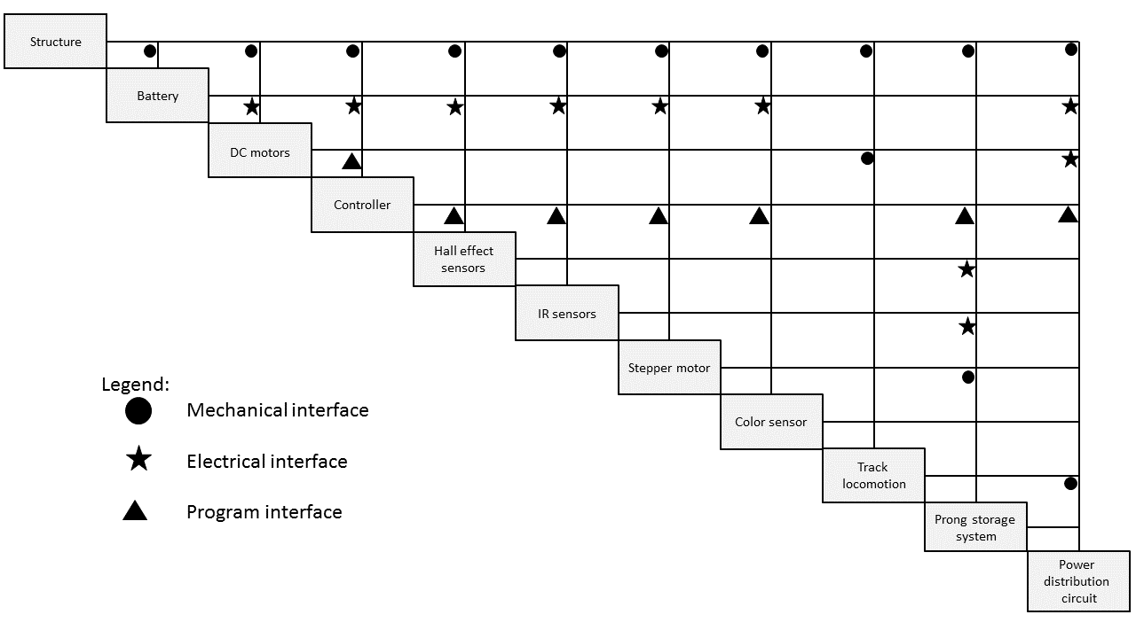

Figure : N2 diagram showing module relations

# 5.0 Concept Evaluation

The following section contains an evaluation of each section separately. Calculations have been done only in the case that some aspect of the concept may not work under the restrictions we have, such as power consumption.

## 5.1 Evaluation of Concept 1

### Robustness

With the Perspex frame at the front of the robot a solid barrier is the first point of contact. This is good because small parts won’t break off when in contact with obstacles. The magnets out the front might come into contact with the other robot and attach to the robot. If this happens there will be no way to detach without dropping our packages. The robot may be more prone to front weight distribution. If a package free in the arena is knocked over on its side the magnets will be able to pick it up.

### Reliability

The magnets will be industrial grade and not be prone to chipping or lose of magnetism. This concept heavily relies on the pathfinding algorithm to work. If it map is incorrect the robot will not know where it has been or has to go. If the map works but the sensors don’t give reliable information the algorithm won’t know where to go and will get confused. Gears slipping in the pickup mechanism could also be a problem.

### Ease of build

The pickup mechanism will be the hardest part to build as it has a complex gearing system. This will take planning and will have small tolerances. Because the build is only a few moving parts it won’t take very long to get things fabricated. The difficult part of this design is getting the code and algorithms working, as the RAM in the ADK will become an issue. The map must be split into a grid, and if split into 4cm square segments with 1 byte per node, will have the following memory usage:

$$2.4×\left(\frac{100}{4}\right)×4.9×\left(\frac{100}{4}\right)=7.35kB$$

The Arduino Mega ADK has 8kB of SRAM, so that would be cutting it very fine. Implementing pathfinding could easily double the requirements, meaning there would have to be some work-around, such as external storage. Discuss noise of sensors?

### Maintenance

With the front of the robot having a Perspex sheet, access from the top of the robot will be easy and preferred. The main controller and battery will be able to be removed via a quick release mechanism. The pickup assembly will be able to be fully detached easily for maintenance inside the chassis or to work on the pickup assembly.

### Modularity

This concept is very modular, as the pickup mechanism will work for a variety of tactics. Conversely, the tactic could use any range of collection methods without impeding its functionality. If anything needed to be changed later on in the process, it could be done.

### Cost

* Arduino external storage | $10
* 3x Magnets | $15

Total = $25

## 5.2 Concept 2

### Robustness

Since this robot has no moving parts (besides the tracks), this design is about as robust as it gets. It will be important to ensure that the sensors are well attached and not prone to being knocked off. Another major consideration of this robot compared to the other two is its power consumption – it must be able to last the whole round (R1.4). Assuming ten electromagnets each at 12V, 3W:

$$I=\frac{P}{V}$$

$$I=10×\frac{3}{12}=2.5 Amps$$

If the battery has a capacity of 4Ahrs, lasting the whole round wouldn’t be a problem.

### Reliability

While being very robust, this concept is not very reliable. It is possible for the robot to get lost in the map and unable to find HQ, and it’s also possible for the packages to get removed by obstacles. These are both crippling problems with this concept.

### Ease of build

Again, due to the lack of moving parts, this robot would be very simple to create, unless an extra power management circuit board is required. Even in this case, the only complexity would be in designing the board rather than physical assembly.

### Maintenance

As with Concept 1, there is a quick release mechanism for the controller and battery. There are almost no other parts inside, so there will be lots of space to work in, and the other functional parts are all external. As long as the brackets are designed decently, maintenance would be trivial.

### Modularity

While the tactic employed is not restrained to the chosen method of package collection, this concept is not very modular. If we found that the electromagnets would not work, for example, the robot would have to undergo a massive overhaul and redesign costing many hours of work.

### Cost

<http://www.aliexpress.com/item/5PCS-of-DC-12V-3W-Holding-Electromagnet-Lift-Solenoid-2-5Kg-5-6lbs-25N-20mm-New/1742033663.html>

## 5.3 Concept 3

### Robustness

Robot has a sturdy construction and would be difficult to damage. A lack of moving parts will ensure that the robot will be less likely to get damaged during operation. Perspex prongs will allow for a sturdy, lightweight retrieval construction. Sensors will be places in secure locations to prevent damage or disturbance during operation.

### Reliability

The picking up of the packages would be rather complex with this design as careful positioning of the prongs would be required. Once a lighter package has been ejected from the robot then it must be able to move and pick up the heavier package without the ejected package interfering. Picking up packages that are along the edges of the arena or in tight spots could not be retrieved by this robot. Randomly driving around the arena is a very inefficient method of collecting packages as since there is no returning to the headquarters, the robot must pick up the heaviest package in order to have a chance at winning.

### Ease of build

The majority of the robot would be fairly simple to construct as it would use the provided chassis. The retrieval construction would be difficult to build as the design requires Hall Effect sensors, strain gauges, and stepper motors to eject the package individually. The tracked design would be easy to implement as it is standard across all concept designs.

### Maintenance

The design would use the Perspex quick release mechanism for the controller and battery. The retrieval method requires a fair amount of testing and fine tuning before it could work efficiently. This complexity means that more maintenance would be required on this part.

### Modularity

Other than the retrieval construction, all the parts can be swapped out and replaced with other parts. The retrieval construction is modular in so far as it can be broken down into sensors and Perspex, however it cannot be readily removed without changing the design of the robot significantly.

### Cost

The kit is only provided with one strain gauge sensor. Since there are three sets of prongs to pick up the packages, this design will require three of both strain gauges and Hall Effect sensors. Unless these are provided, they must be purchased with the design budget. Most of the other parts are provided in the kit.

<http://www.aliexpress.com/item/Hall-effect-Sensor-CHE12-10N11-H710/485098841.html>

<http://www.dfrobot.com/index.php?route=product/product&product_id=1031&search=weight&description=true>

## 5.4 Final Comparison

|  |  |  |  |  |
| --- | --- | --- | --- | --- |
|  | Weighting | Concept 1 | Concept 2 | Concept 3 |
| Robustness | 8 | 8 | 9 | 8 |
| Reliability | 9 | 8 | 4 | 6 |
| Ease of build | 6 | 6 | 9 | 5 |
| Maintenance | 7 | 8 | 9 | 6 |
| Modularity | 8 | 9 | 2 | 5 |
| Total |  | 300 | 241 | 230 |

Table 3: Merit Table of concepts

Cost estimation should go here, should be fairly easy to do ☺

Need some basic/approximate calculations or estimates of costs, forces, power requirements, available computation and memory. Evaluate/compare the concepts – FOM table. This doesn’t need to be exquisitely detailed or accurate at this stage – just provide enough to be able to evaluate and compare the concepts in a relatively objective manner. Briefly discuss/comment on these 3 concepts in the context of the competition and specs – factors such as robustness, reliability, ease of build and maintenance between rounds, modularity, and cost.

# 6.0 Conclusions and Recommendations

Based on the evaluations of the three concept designs stated in this report, our team has concluded that the optimum design for the Robocup challenge would be concept one.

Concept one has a robust design that can pick up the packages in a variety of different orientations. This allows for the picking up and retrieval of more packages and therefore increasing the chance of the robot winning the round. Its complex path finding and sensor array will enable this robot to navigate through the arena whilst it searches and retrieves packages. At HQ the magnets used to secure the packages can be retracted, allowing the packages to be dropped off easily. The tracked design, along with 3D printed wheels, will allow for easy traversing of the varying terrain types that can be encountered in the arena. Overall we believe that this concept will produce a robot that is ideally suited for the Robocup competition.

# Contribution Statements

## Jack Hendrikz

* Concept 3 description and evaluation
* Description of locomotion and chassis design
* General documentation formatting
* Conclusion
* Abstract

## Peter Nicholls

* Concept 2 description and evaluation
* Description of tactics
* Requirements specification
* Document Formatting

## Ryan Taylor

* Concept 1 description, evaluation and sketch
* Sensor concept development
* FSM, figure 2
* Introduction